

Play and guess the song



What is song?

Intro...
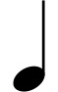
x9
1.
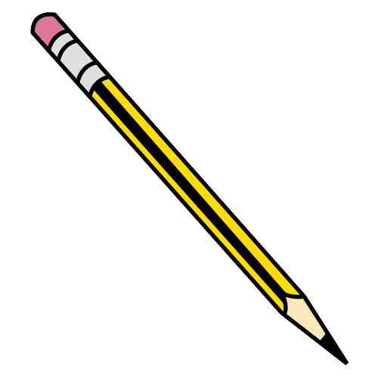
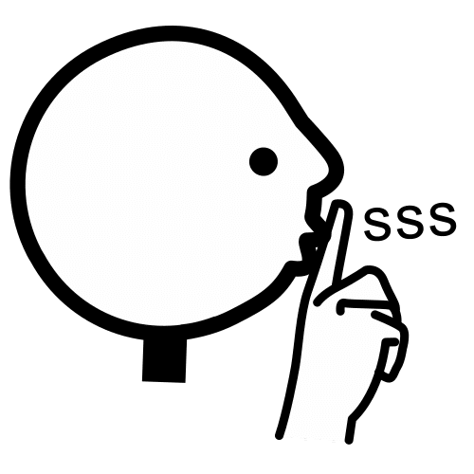

2.
x1

3.
x13

4.
x1



5.
x12

6.
x12

Solo...

Comets
Asteroids



