

The journey of the Earth and the Moon



Writing

1. Read and write 1, 2 or 3 words.
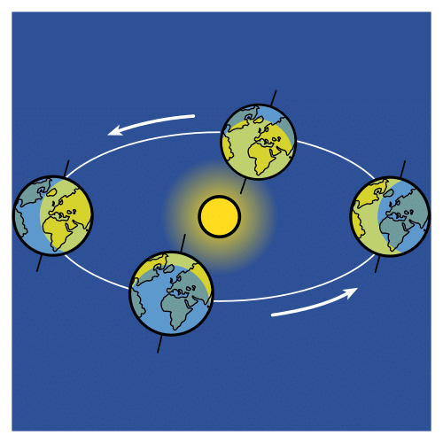
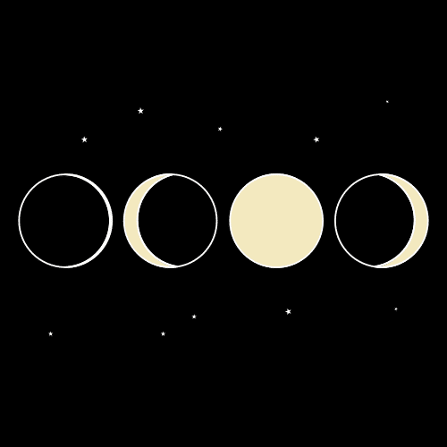

The Earth | The Moon
- The Earth is a …………………...……………...……… (1)  - The Earth’s movements are ………………….…..  …………………...……… and …………….………………… (2)  - The ……………………..………………………….…… (3) of rotation causes ……………………….……………………  ……………………...……… and …………..………………… (4)  - The ………………..………………………………………………. …………………………………..…………..…………….…… (5) spring, summer, autumn, and winter. | - The Moon is a satellite.  - The Moon’s ……………………………………..... ………..…………. (6) rotation and orbit.  - These movements cause the ………….. …………………………………………………….…… and …………………………………………………………… (7)



