

News from space





Read, listen and correct

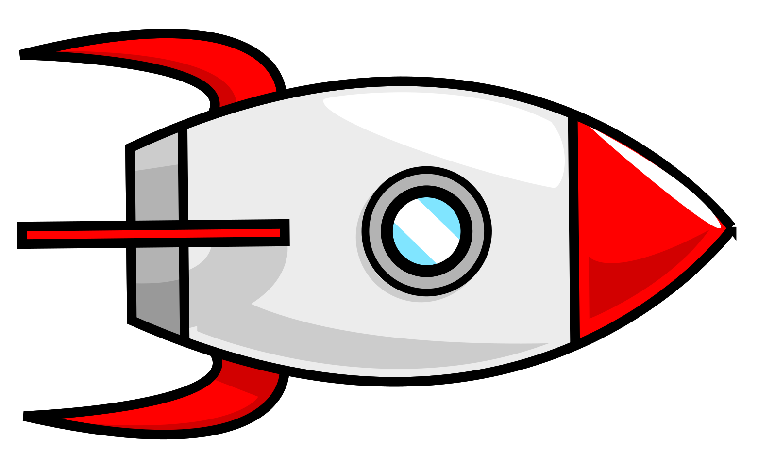
a) Read the text of this astronaut and find the mistakes.
News from Space!
Date: March 2024
The Solar System is very big. It has 9 planets. The planets go around the Sun. The first planet is Mercury. It is small. The second planet is Venus. It is the biggest planet. The Earth is our home. It has water and trees. Mars is green and very hot. Jupiter is very small and has many moons. Saturn is the planet with rings. Uranus is very far away and hot. Neptune is the last planet. It is blue and made of rock.
There are also many stars, asteroids and comets in space. Stars are very bright and big. Asteroids are tiny rocks. Comets are small and they have tails.

b) Rewrite the text and correct the mistakes.
………………………………………………...…...…………………………….…….
………………………………………………………..……...…...…….…………………………..………………………………………………...…...…….…………………………………………...…...…………………………………….……………………..
………………………………………………...…...…………………..……………… ………………………………………………...…...…………………………….…….
………………………………………………………..……...…...…….…………………………..………………………………………………...…...…….…………………………………………...…...…………………………………….……………………..
………………………………………………...…...…………………..……………….………………………………………………...…...…………………………….……
………………………………………………………..……...…...…….…………………………..………………………………………………...…...…….…………………………………………...…...…………………………………….……………………..
………………………………………………...…...…………………..……………….

c) Listen to the corrected text. Check if your answers are right!

