

Guess the planet





Celestial bodies in the Solar System

Ask and answer to the questions. Try to guess the planet.

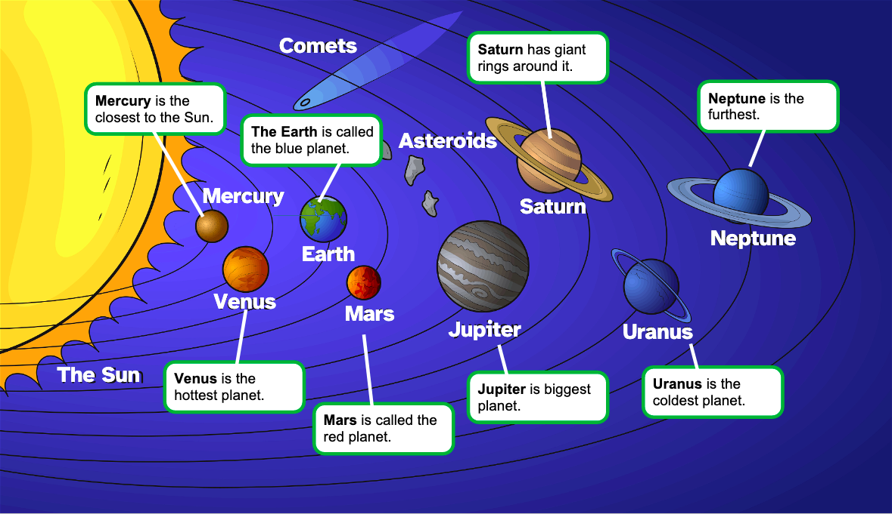
 | QUESTION | ANSWER
 | Hi! | Hello…
COLOUR | What’s your colour? | My colour is…
TEMPERATURE | Are you hot or cold? | I’m (cold, hot).
SIZE | What’s your size? | I’m (big, small).
MADE UP OF | What are you made up of? | I’m made up of (ice, rock, gas…).
ORDER | What’s your order? | I’m the (first planet, the second planet, etc.).
 | You are… | Yes, I am / No, I’m not.

