

Destination: Europa



Plan your space mission to Europa

To complete the following information, you can use the internet.

1. LABEL AND DRAW YOUR ROUTE
Label the Sun, planets and satellites of the Solar System in the picture. Then, draw the route your spaceship will pass by from Earth to Europa.

2. WHAT WILL YOU FIND IN EUROPA?

Distance from the Earth: ________________________________________. TEMPERATURE:
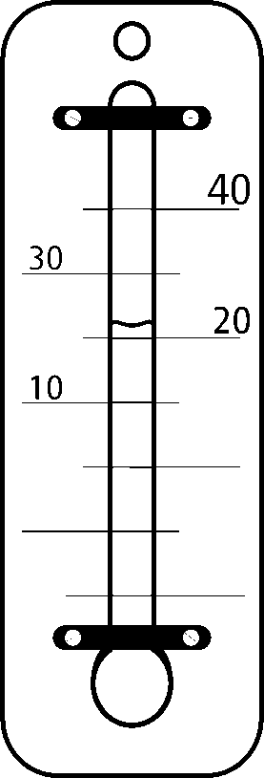
How big is it?: ____________________________ than the Earth.
Days to revolve Jupiter: It takes__________________________________.
Days to rotate on itself: It takes__________________________________.
250ºC
0ºC
INTERESTING FACTS ABOUT EUROPA
150ºC
-50ºC
………………………………………..
………………………………………..
………………………………………..
………………………………………..
………………………………………..
………………………………………..
………………………………………..
………………………………………..
………………………………………..
-100ºC
………………………………………..
………………………………………..
………………………………………..
………………………………………..
………………………………………..
………………………………………..
………………………………………..
………………………………………..
………………………………………..
…………………..………………..…..…..
…………………..………………..…..…..
…………………..………………..…..…..
…………………..………………..…..…..
…………………..………………..…..…..
…………………..………………..…..…..
…………………..………………..…..…..
…………………..………………..…..…..
…………………..………………..…..…..
…………………..………………..…..…..
…………………..………………..…..…..
…………………..………………..…..…..
…………………..………………..…..…..
50ºC
0ºC
-200ºC

Hot
Cold

WHEN WAS IT DISCOVERED?
WHO DISCOVERED IT?

…………….……………...…………..
…………….……………...…………..
…………….……………...…………..
…………….……………...…………..
…………….……………...…………..

Draw a picture of Europa

WHAT IS IT MADE UP OF?

……………...…………………………...…………
……………………………………...…….………..
……………………………………………………..
……………………………………………………..
3. COMPLETE YOUR SPACE DIARY
You're already flying through space!
You are writing in your space diary everything you are observing from your spaceship.
Write 4 sentences using comparative or superlative adjectives to describe the planets or satellites you are passing by.
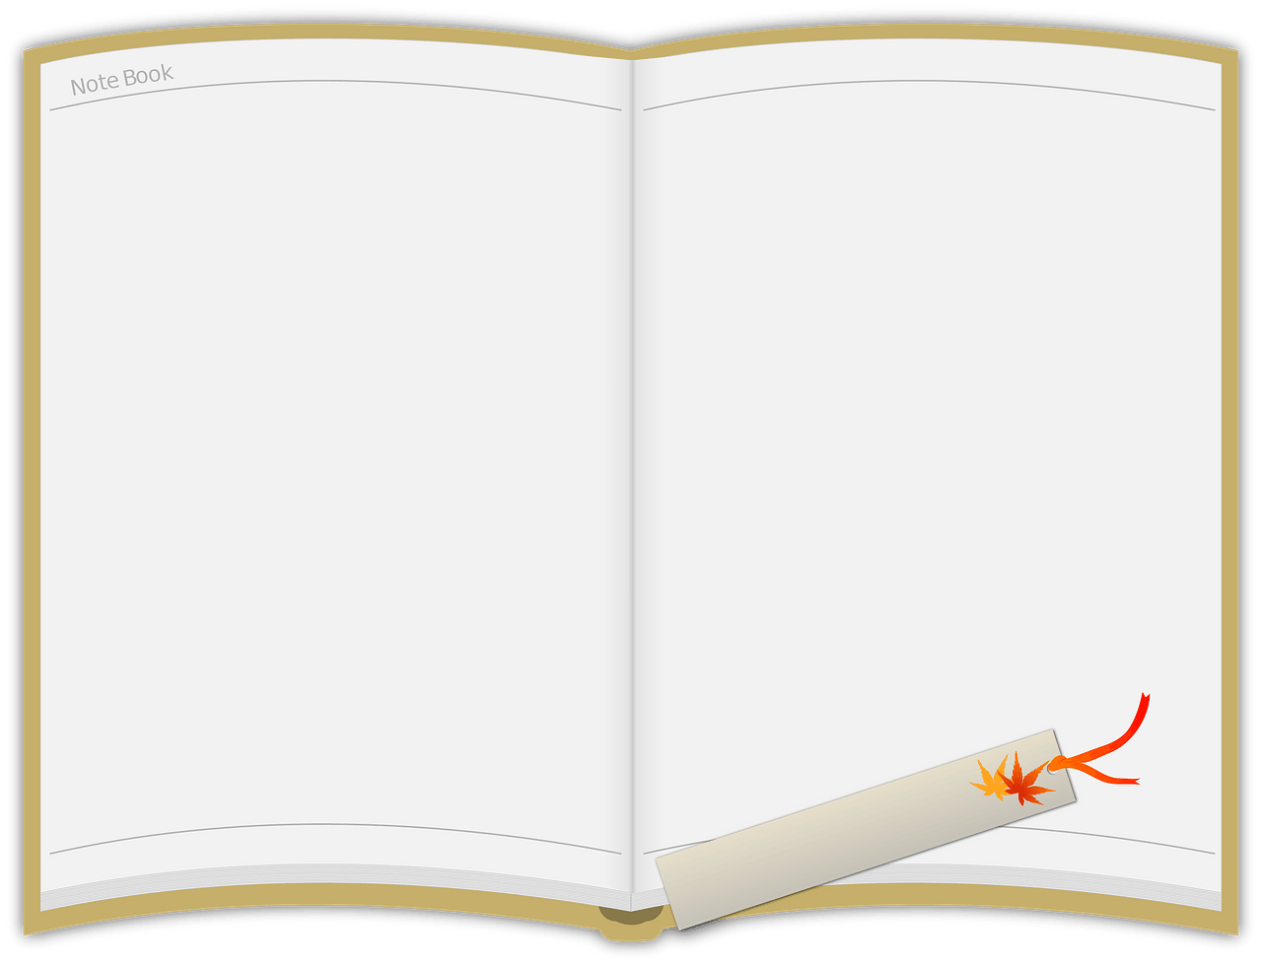
Space mission to Europa
Example:
I can see Mercury, it is the closest planet to the Sun.
……………………………………...…….……………. ……………………………………...…….……………. ……………………………………...…….……………. ……………………………………...…….……………. ……………………………………...…….……………. ……………………………………...…….…………….……………………………………...…….……………. ……………………………………...…….……………. ……………………………………...…….……………. ……………………………………...…….……………. ……………………………………...…….……………. ……………………………………...…….……………. ……....



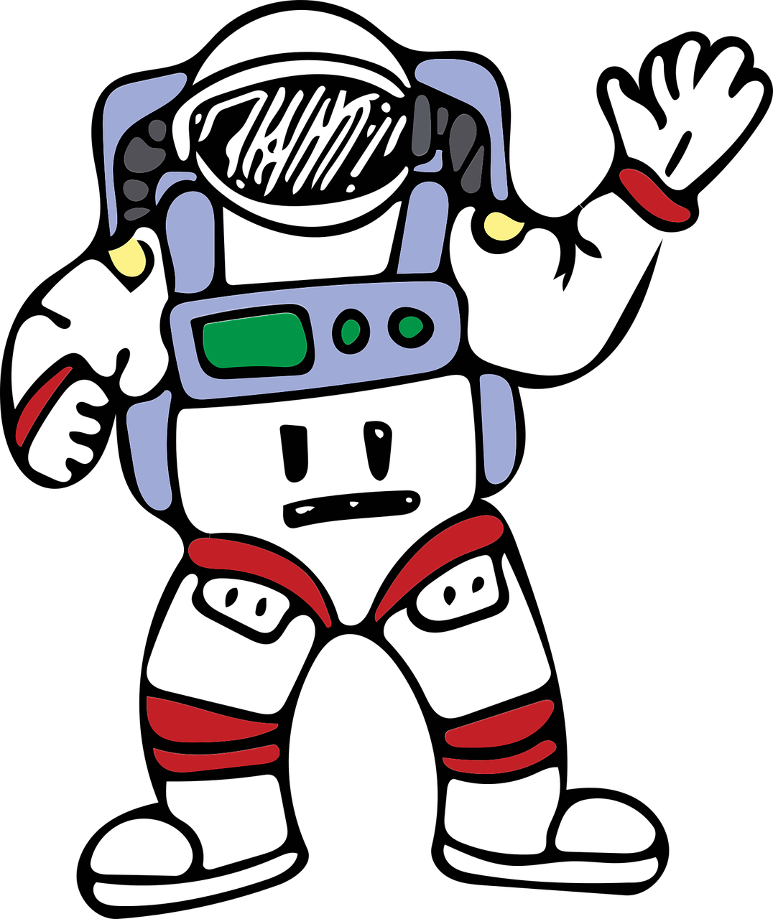

My personal notes



