

Design your own planet



DESIGN YOUR OWN PLANET

NAME OF YOUR PLANET: _____________________ DATE: ____________
DISTANCE FROM THE SUN: ____________________ TEMPERATURE:
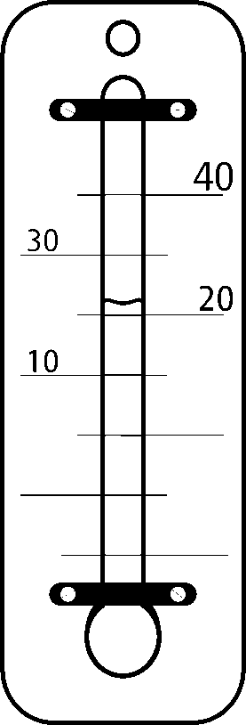
HOW BIG IS IT?: ____________________
NUMBER OF MOONS: ____________________

………………………………………..
………………………………………..
………………………………………..
………………………………………..
………………………………………..
………………………………………..
………………………………………..
………………………………………..
………………………………………..
………………………………………..
………………………………………..
………………………………………..
………………………………………..
………………………………………..
………………………………………..
………………………………………..
………………………………………..
………………………………………..
………………………………………..
………………………………………..
………………………………………..
………………………………………..
………………………………………..
………………………………………..
………………………………………..
………………………………………..
………………………………………..

Draw a picture of your planet

WHO LIVES THERE?

……………...…………………
INTERESTING FACTS ABOUT YOUR PLANET
………………...…….………..
………….………...…………..
ORIGIN OF THE NAME.
WHAT DOES IT MEAN?
……………………...….……..
………………………………..
…………………………………...……..
…………………….…………..………..
…………………………………...……..
……………………………………...…..
……………………………………….....
………………………………………….
………………………………………….
RINGS? HOW MANY?

WHEN WAS IT DISCOVERED?
WHO DISCOVERED IT?




